***Use this word document to describe all your steps after each problem. Show all commands & screen pages and describe your steps. Points are deducted for missing steps.***

***Describe all steps for each problem set and capture screen shots for each step with a JPG image within this document. Do not forget to put your name on the top of this file for your submitted homework. Also, please replace _ALL_ text in red with your information!***

**Problem 1:**

<https://docs.aws.amazon.com/lex/latest/dg/gs-cli-create.html>

Put all your steps and screen captures here.

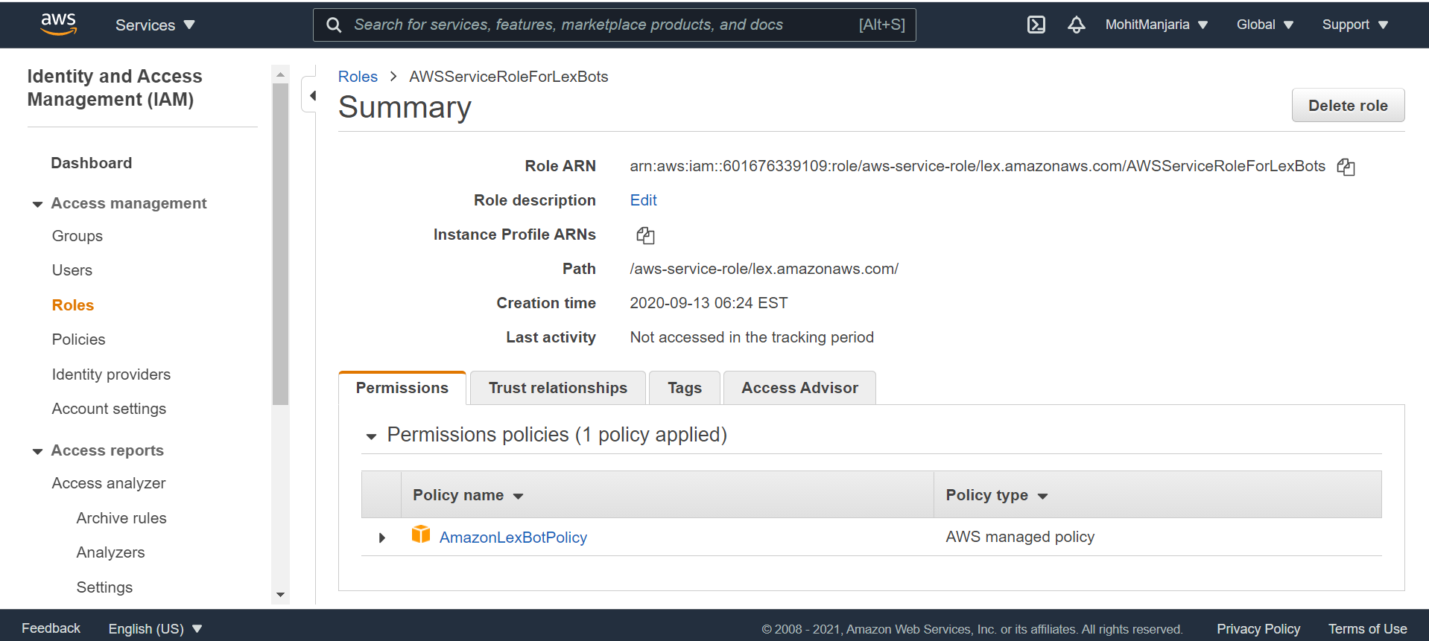

Step 1: Create a Service-linked role (AWS CLI)

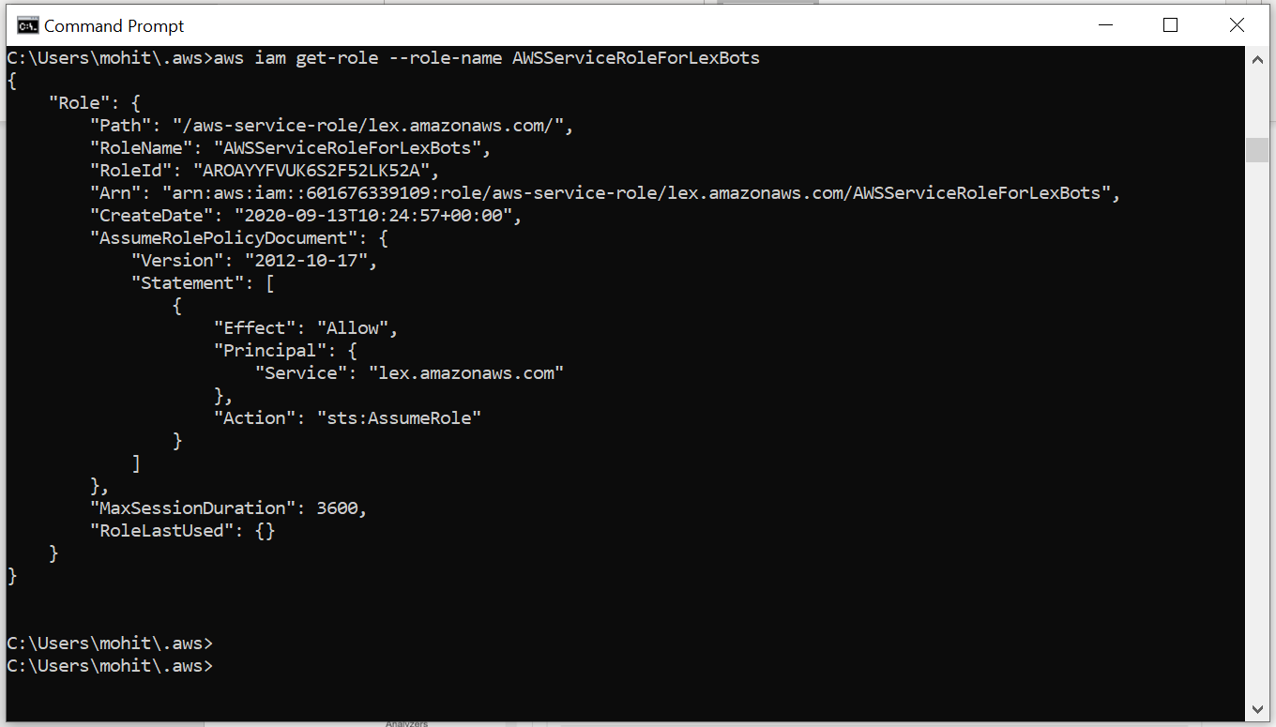

Step 2: Create a Custom Slot Type (AWS CLI)

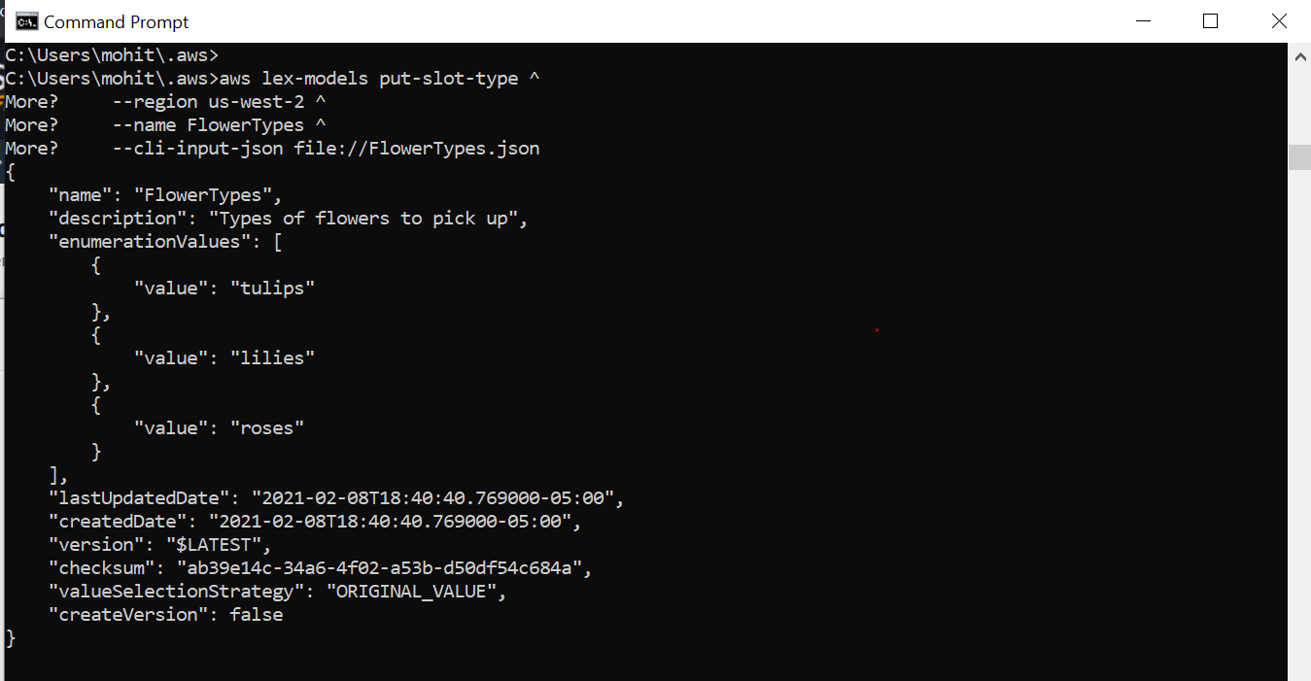

Step 3: Create an Intent (AWS CLI)

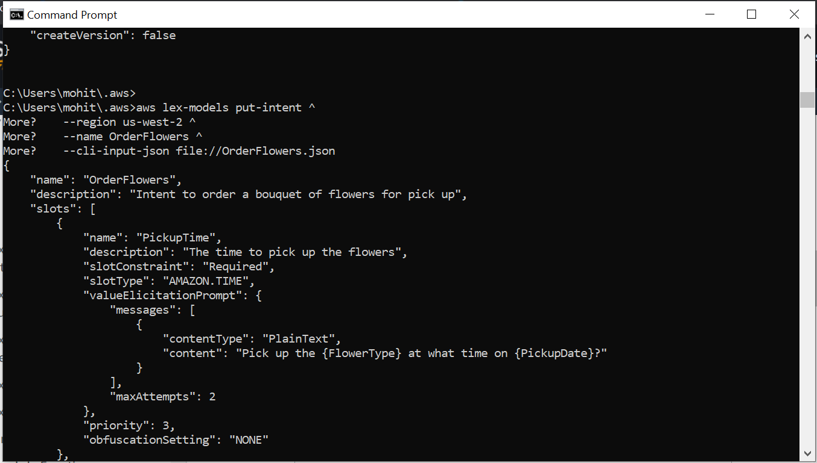

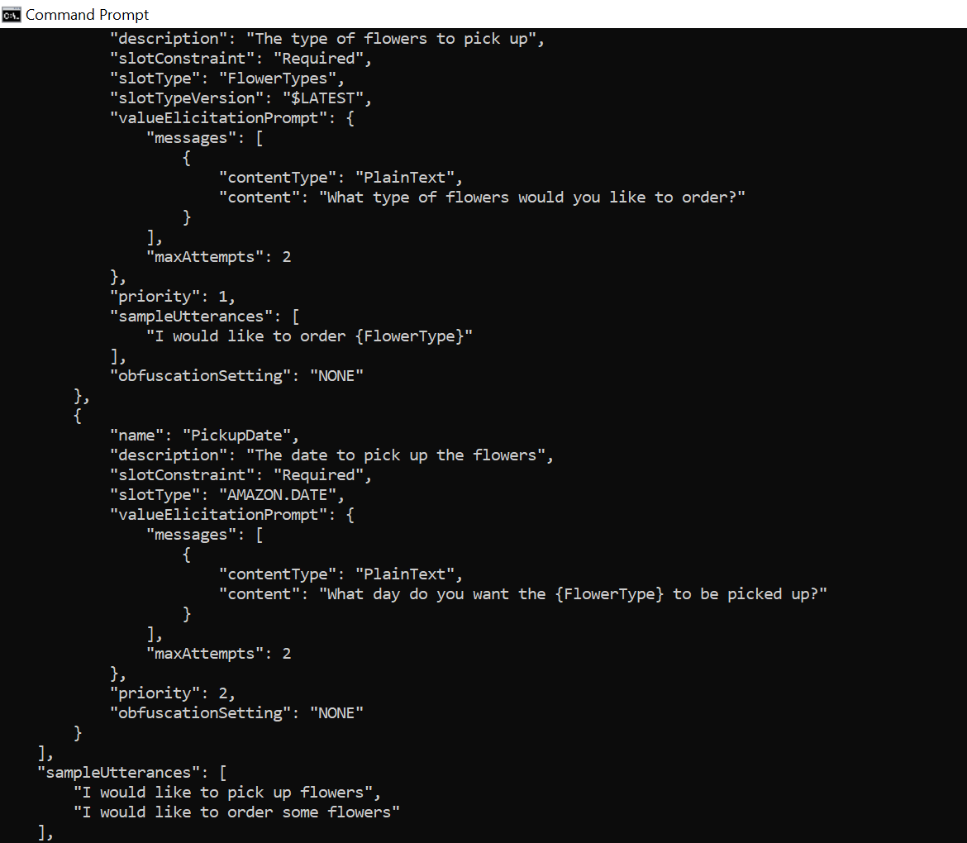 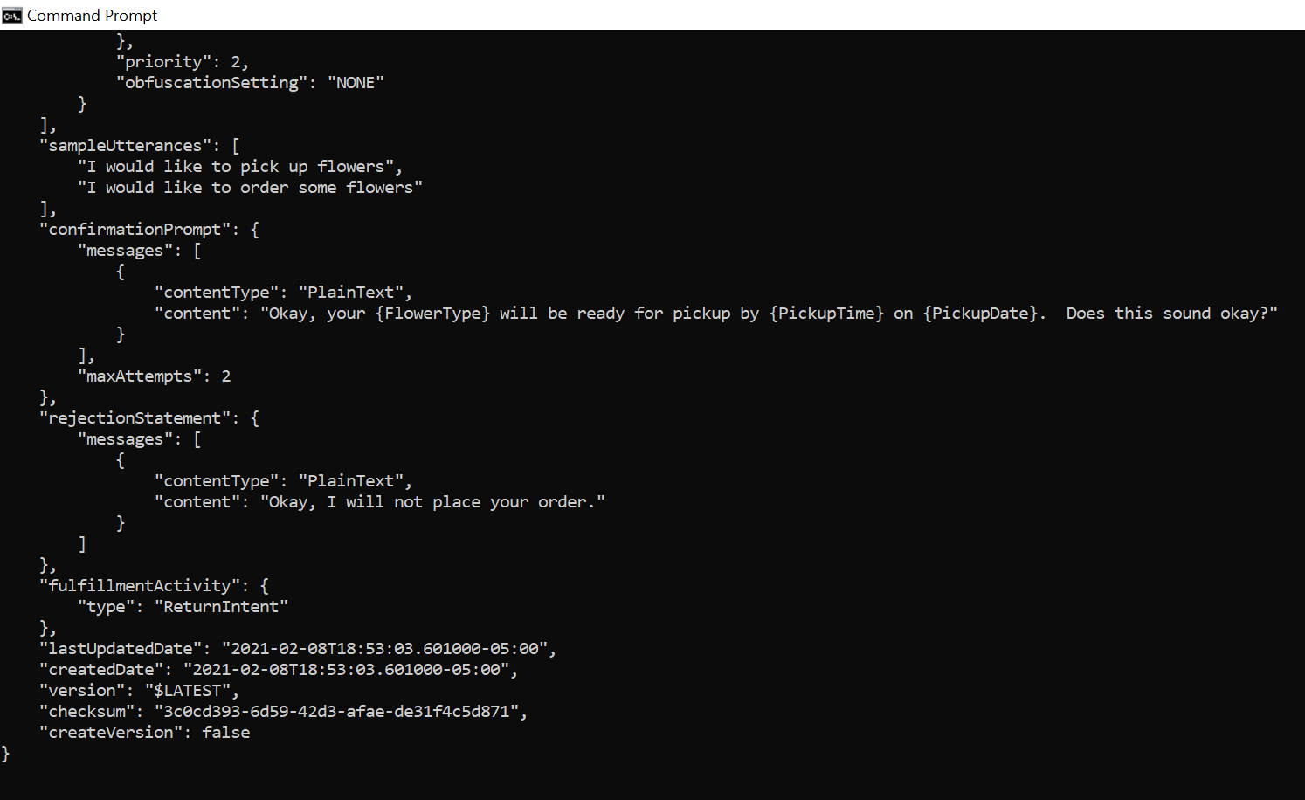

Step 4: Create a bot (AWS CLI)

BOT in building mode

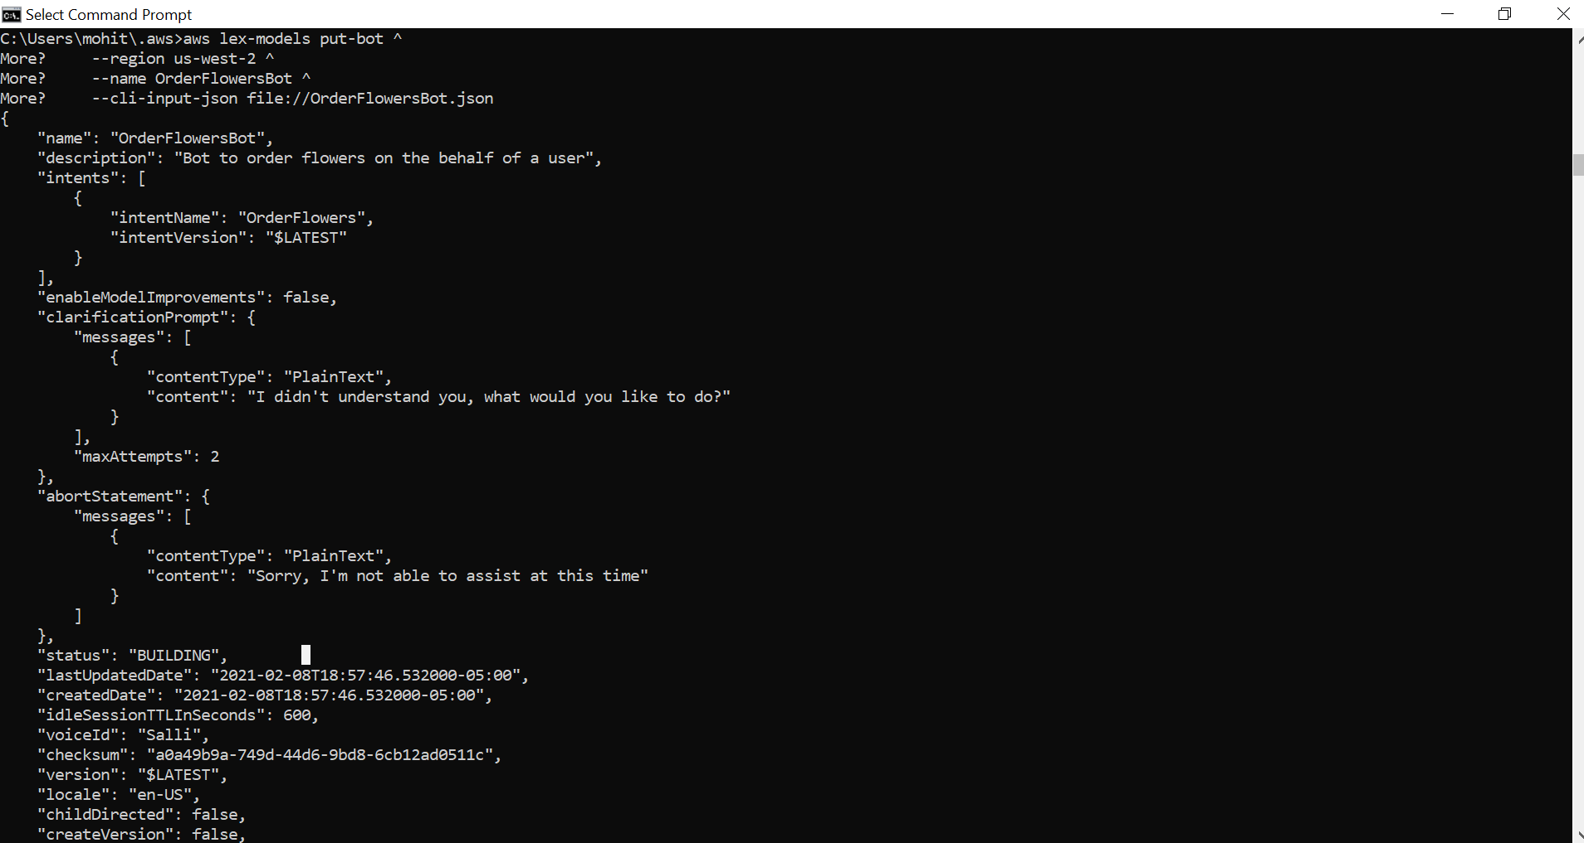

BOT BUILD

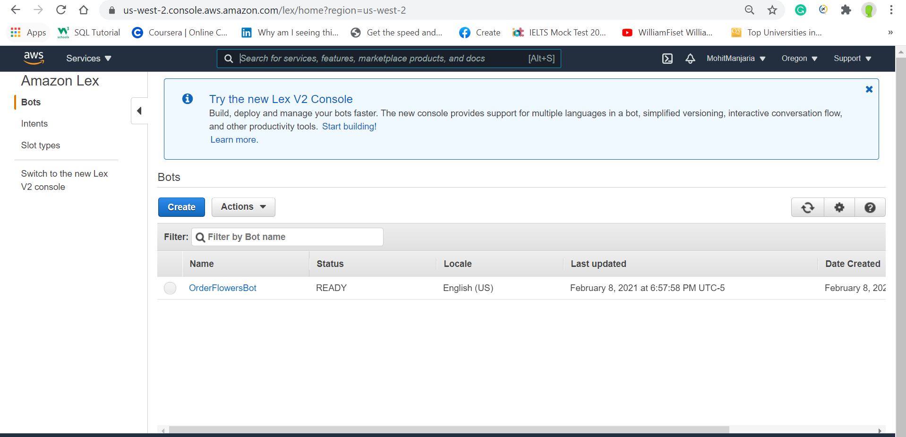

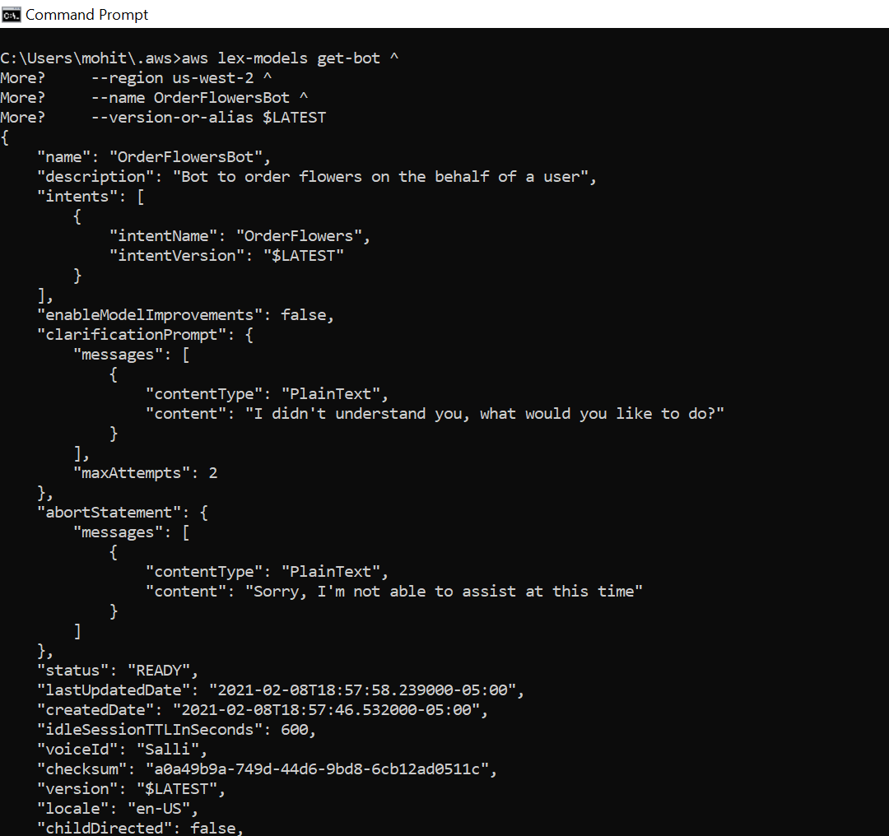

Step 5: Test a bot (AWS CLI)

Test the Bot Using Text Input (AWS CLI)

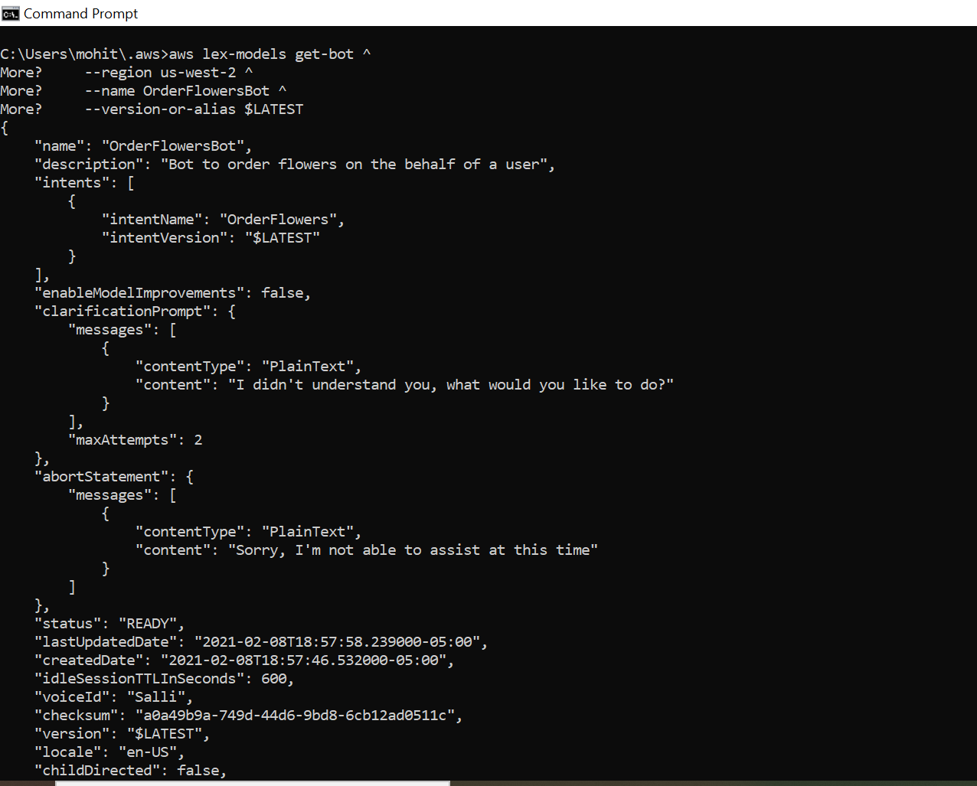

Finish the conversation

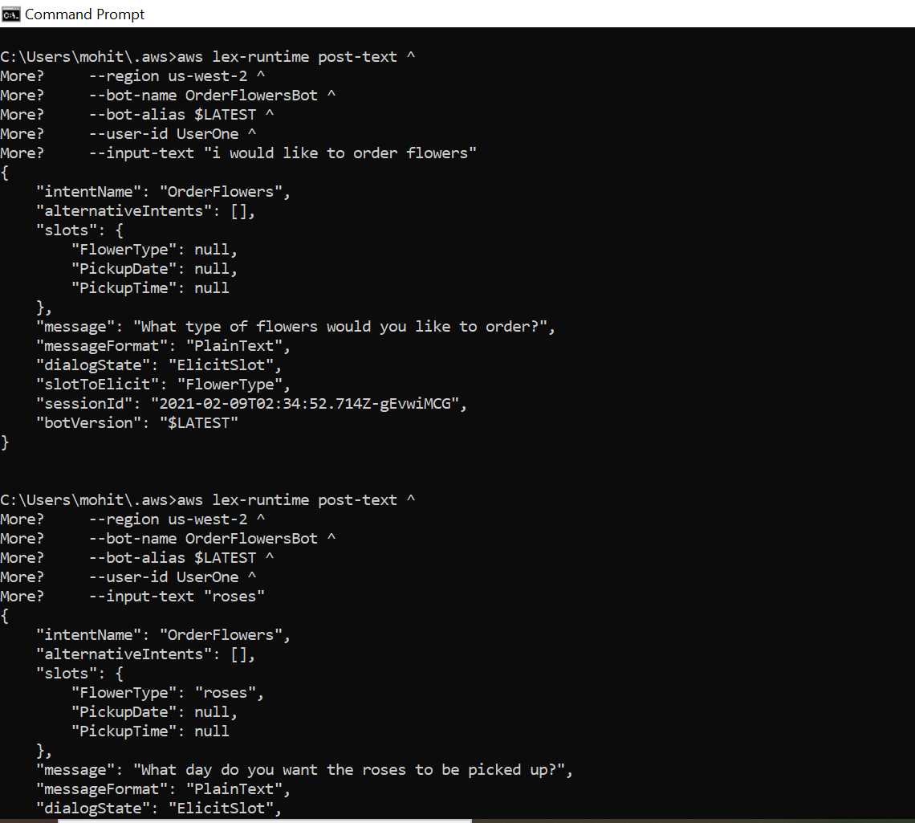

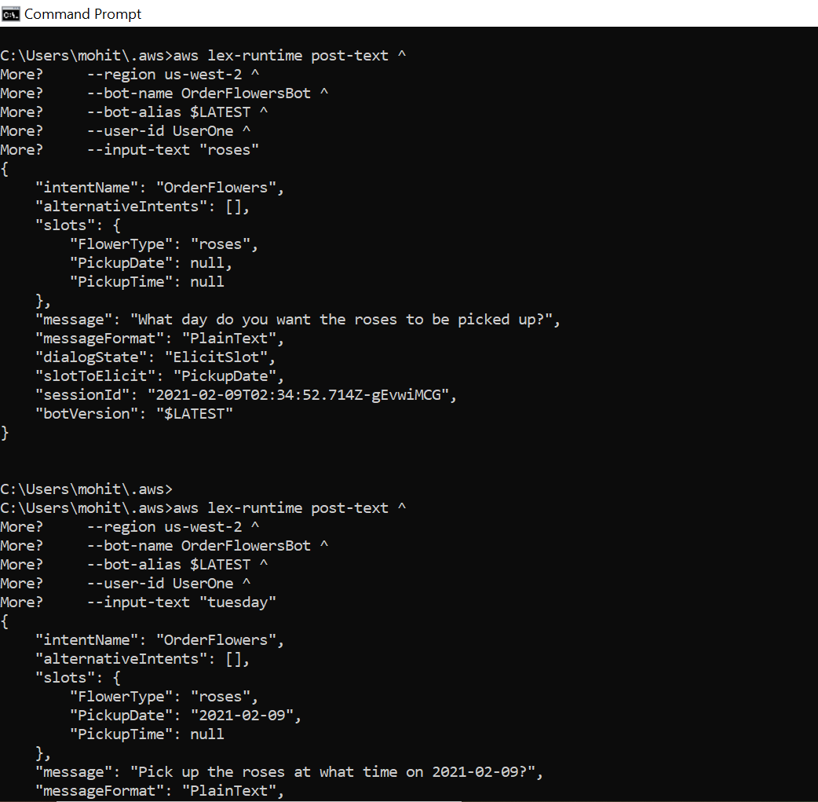

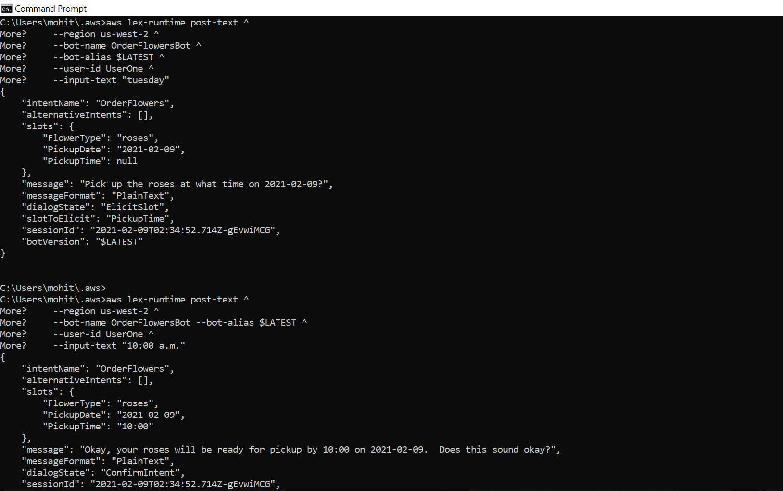

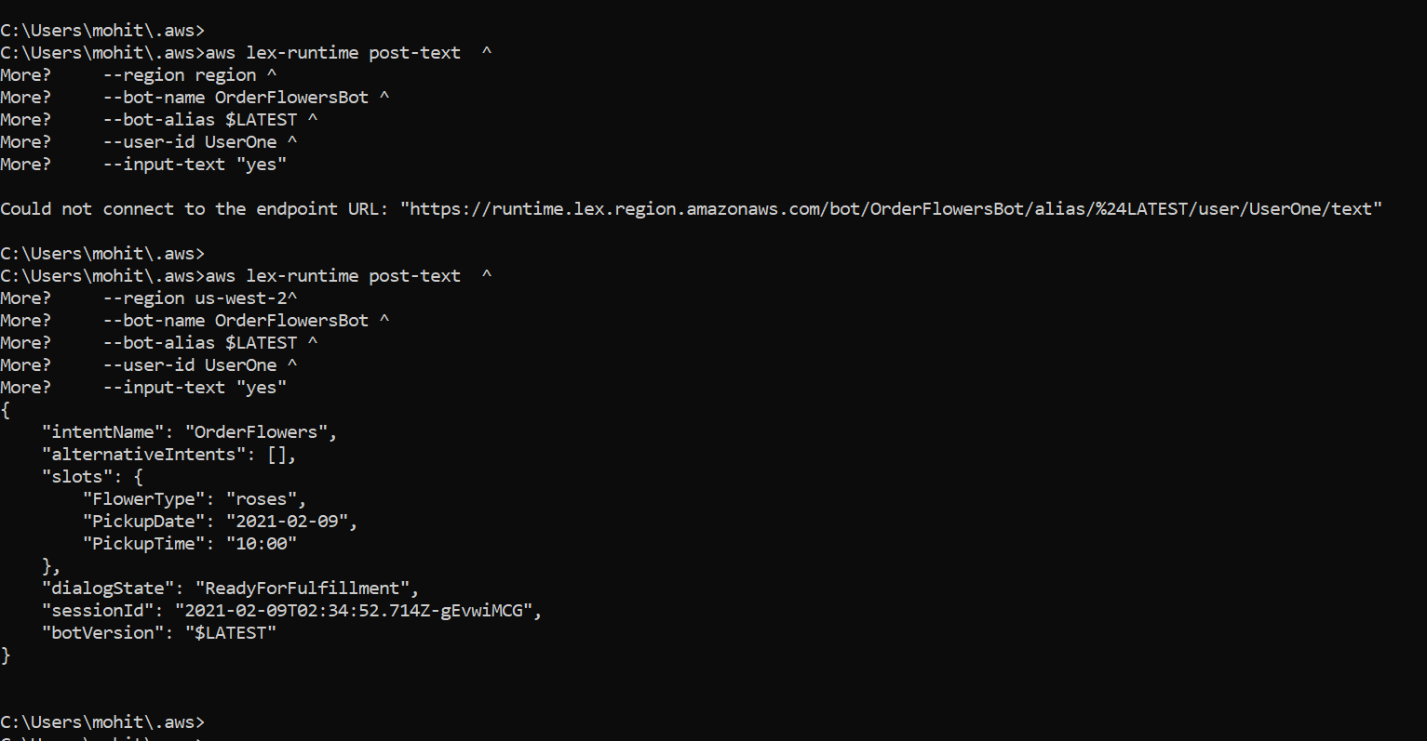

**Total points: 20**

**Problem 2:**

<https://docs.aws.amazon.com/lex/latest/dg/gs-cli-update-utterance.html>

Put all your steps and screen captures here.

**Total points: 20**

**GET INTENT**

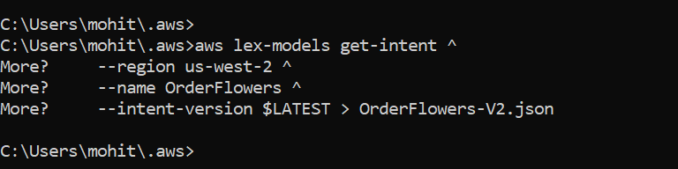

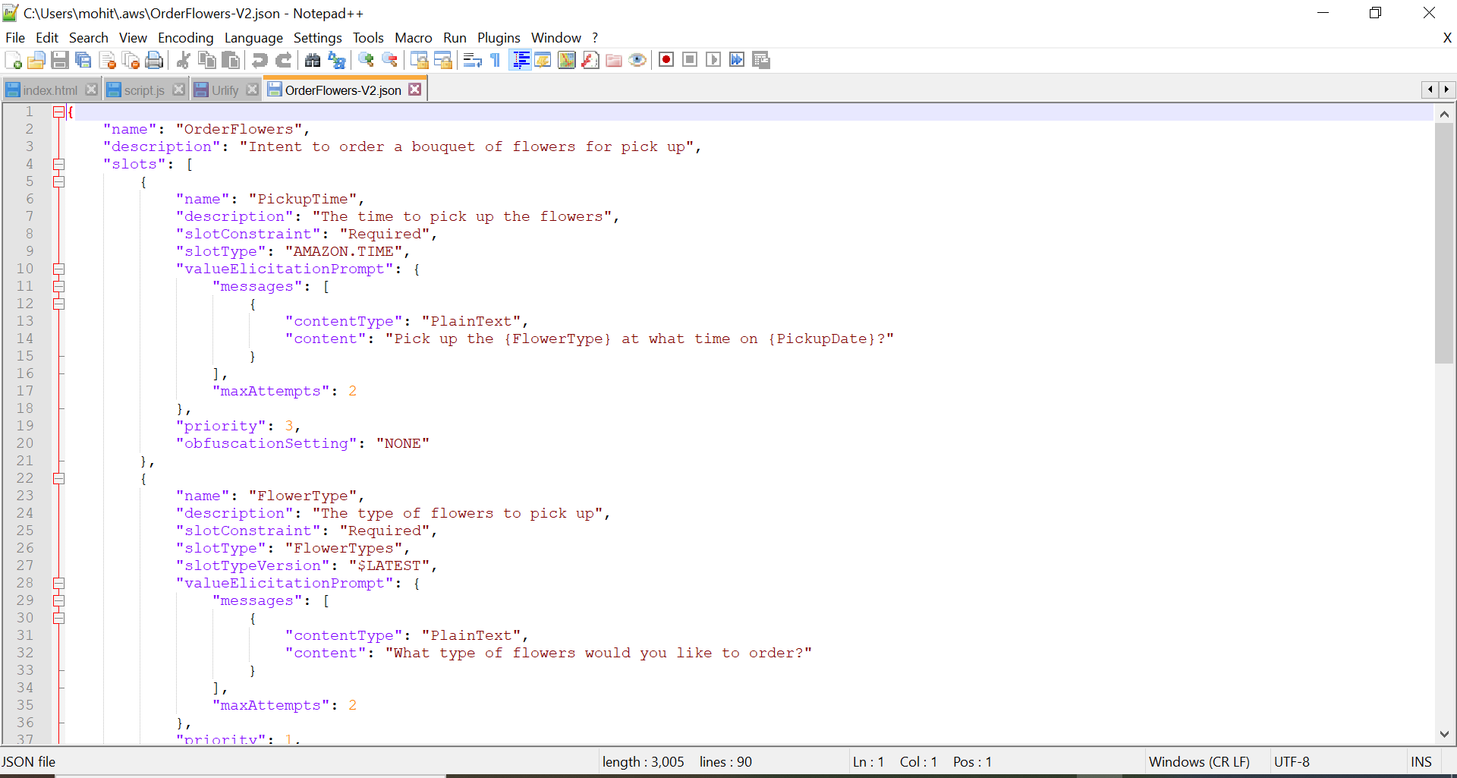

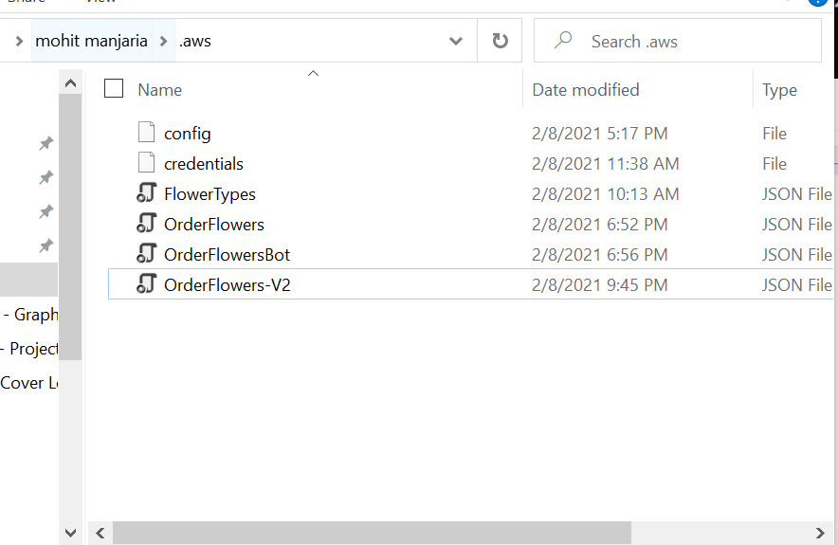

**Removing**

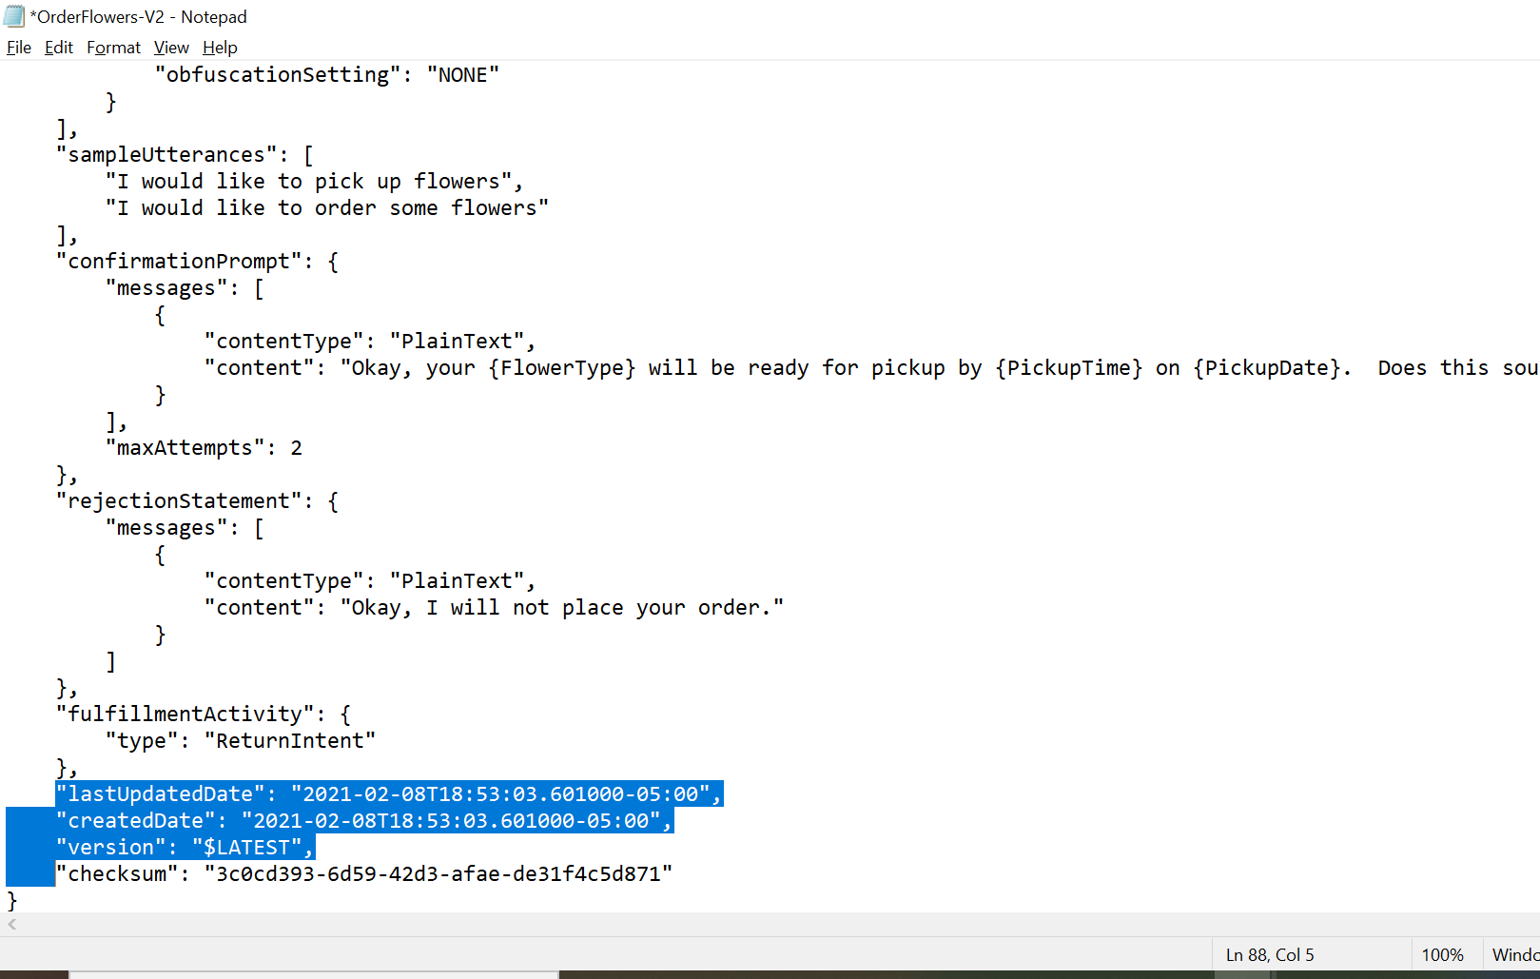

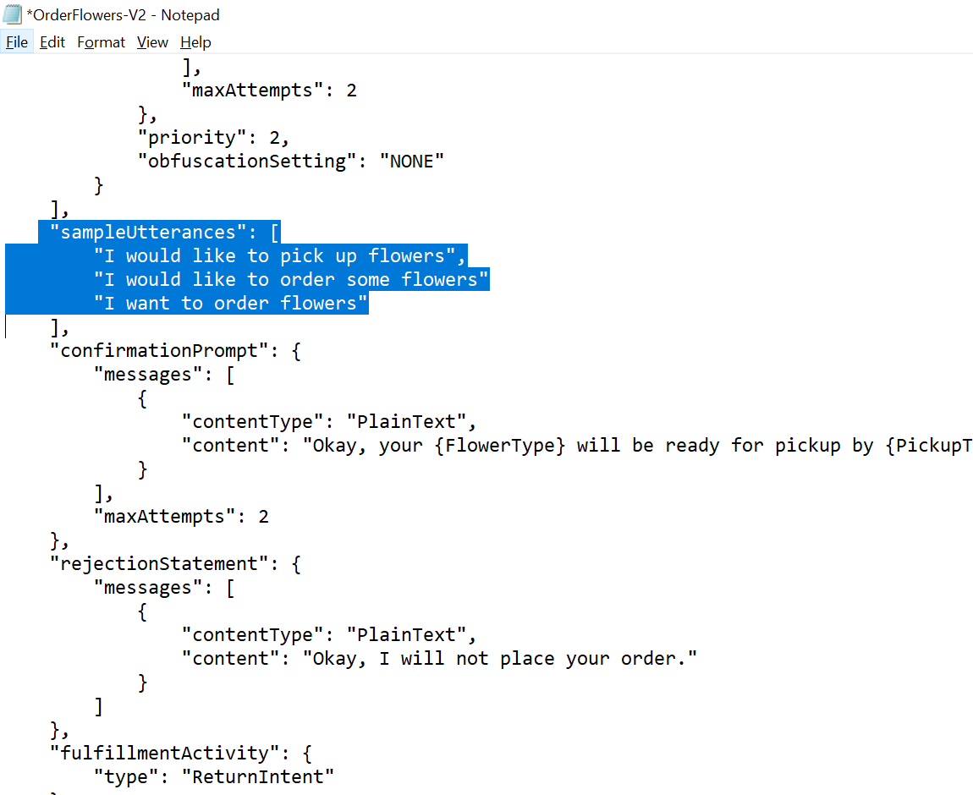

**Update Intent**

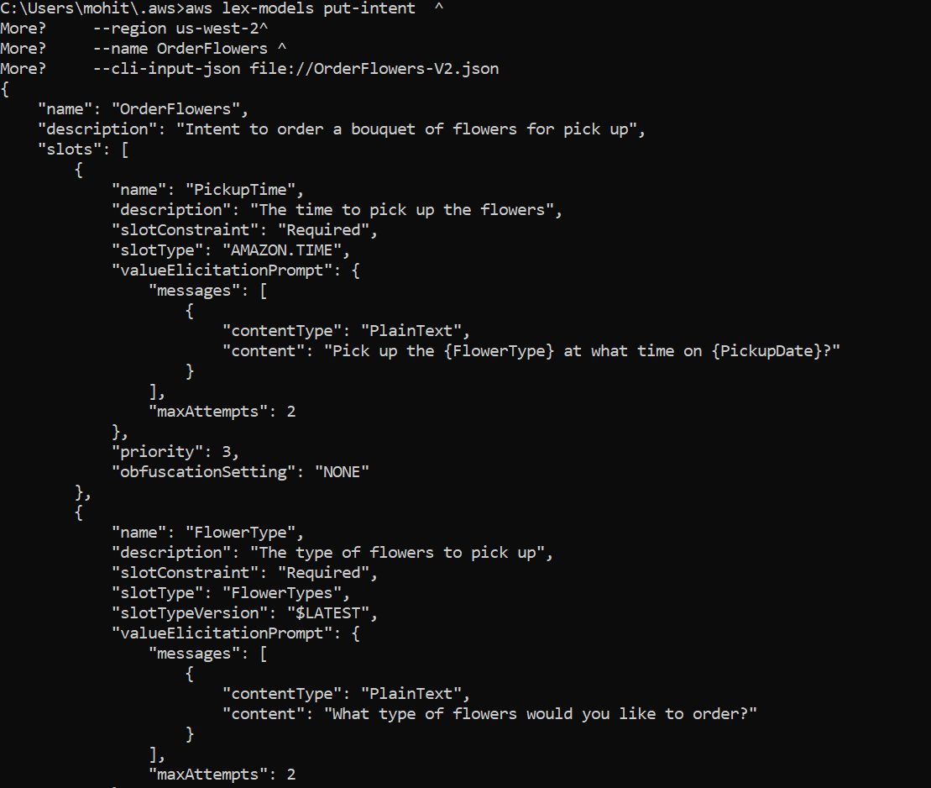

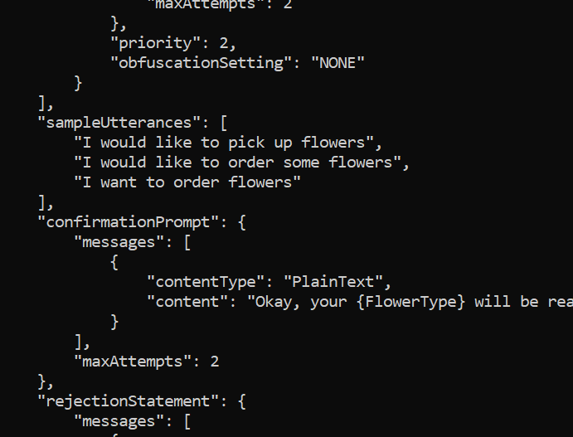

**Definition**

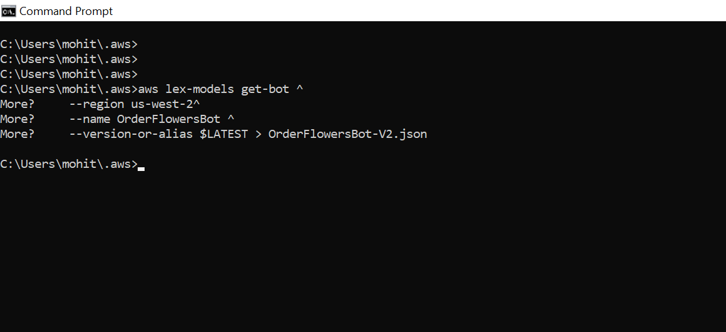

**Removed** createdDate, lastUpdatedDate, status and version fields.

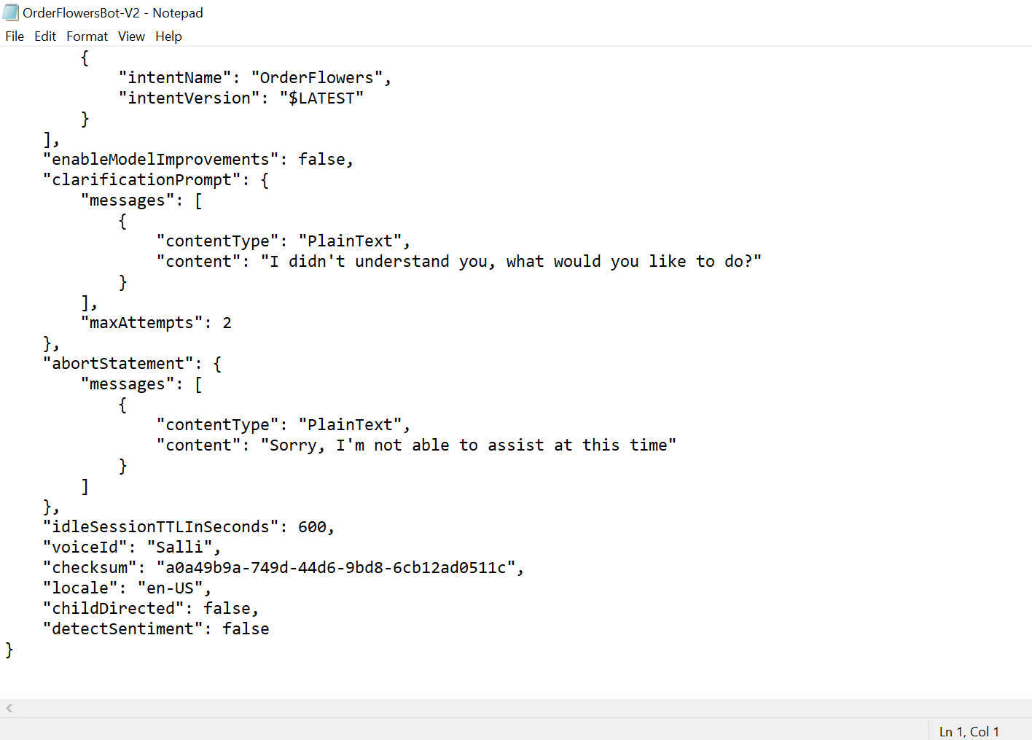

**Bot definition**

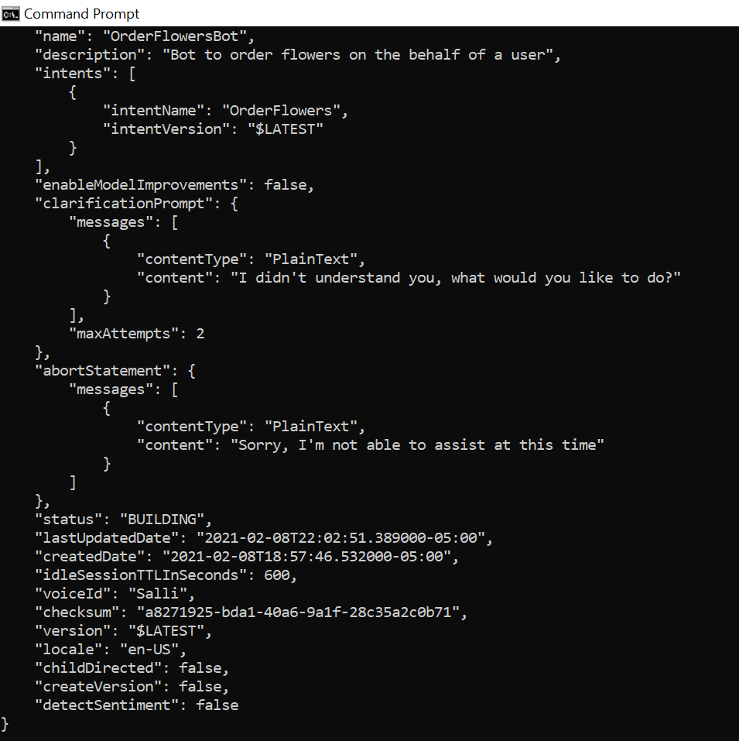

**Problem 3:**

<https://docs.aws.amazon.com/lex/latest/dg/gs-cli-update-lambda.html>

Put all your steps and screen captures here.

**Total points: 20**

**Function created and ran successfully**

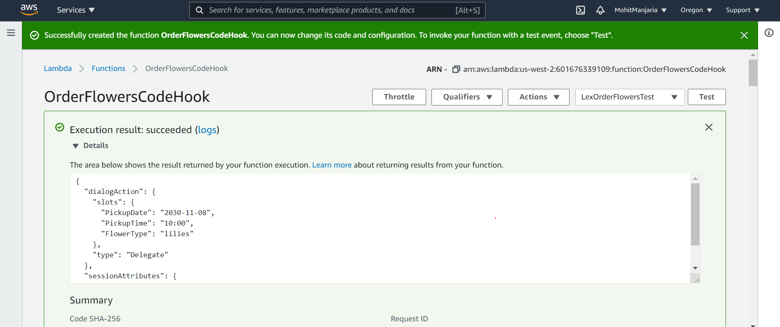

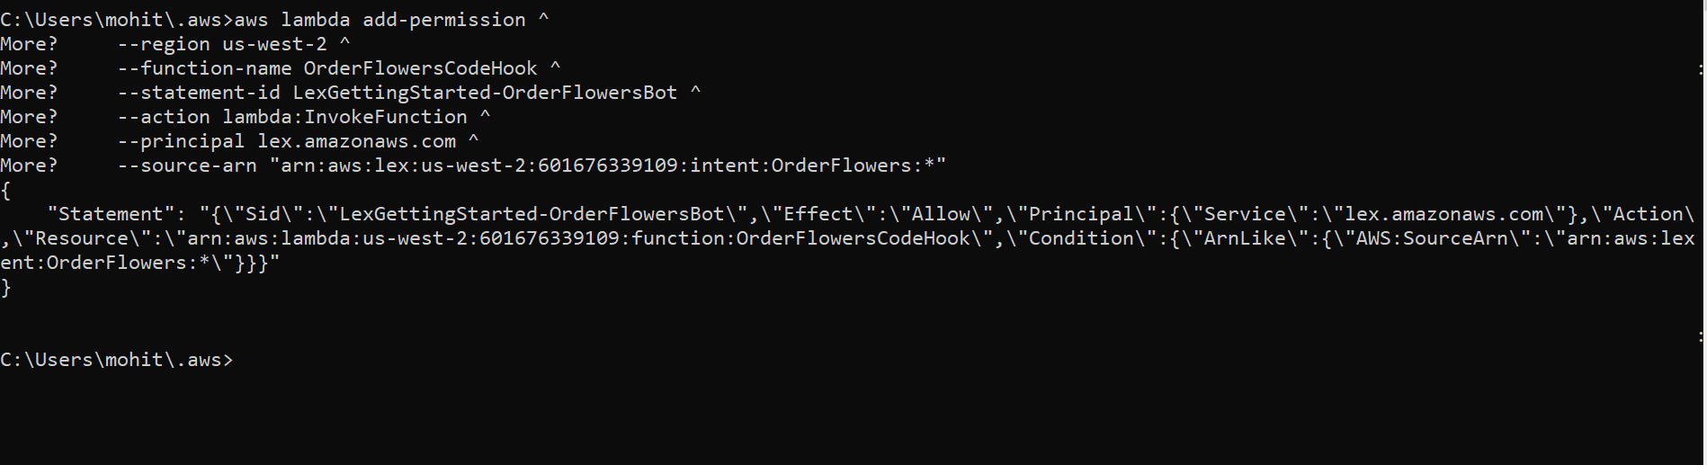

**Get the intent from Amazon Lex. It sends output to a file called OrderFlowers-V3.json**

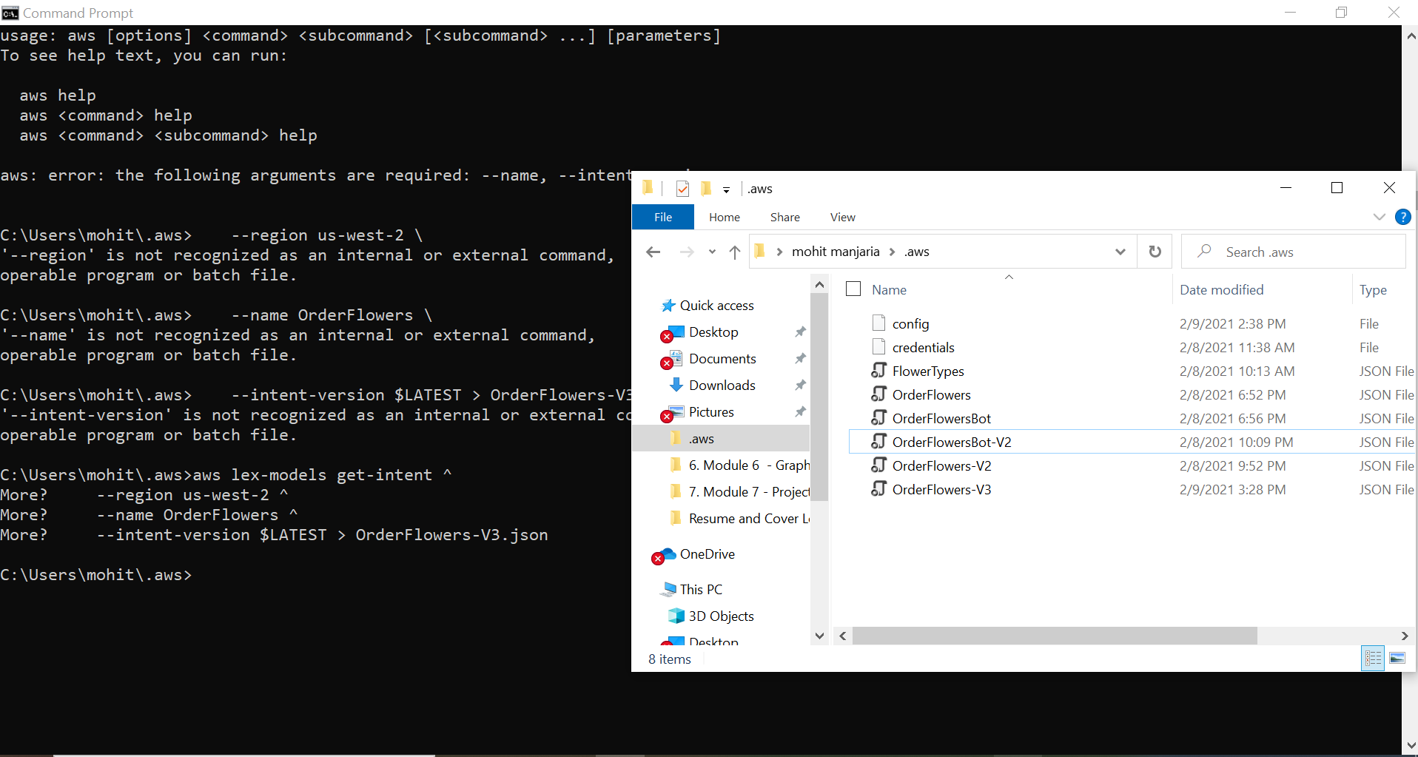

**Send the updated intent**

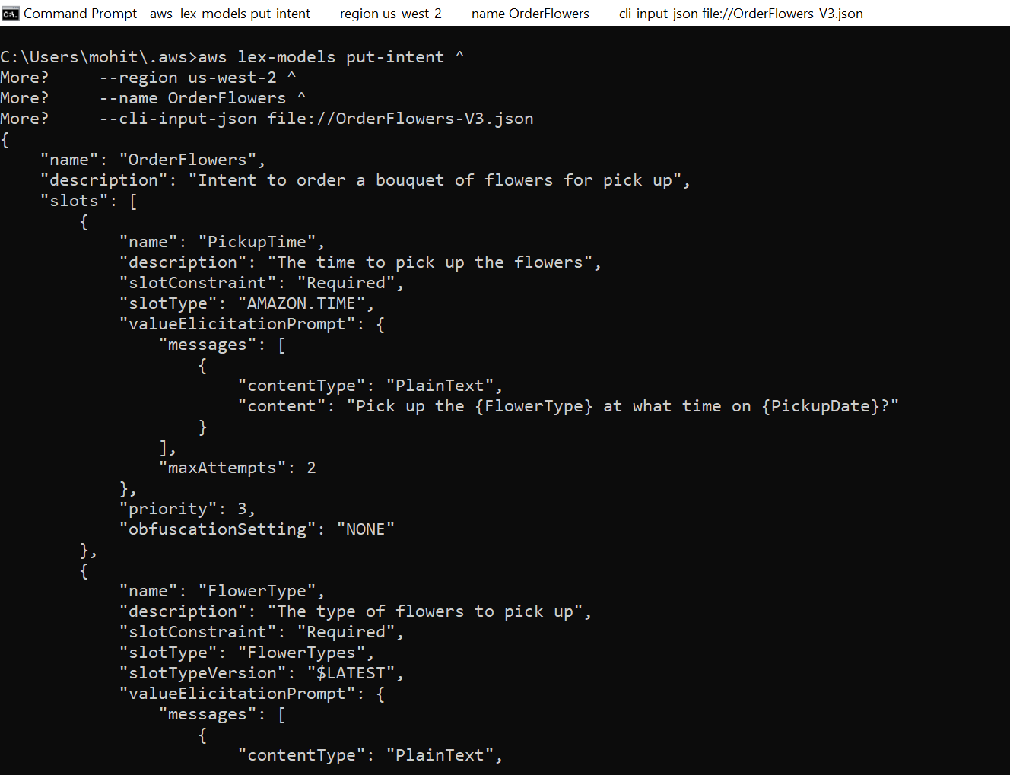

**Rebuild the OrderFlowersBot**

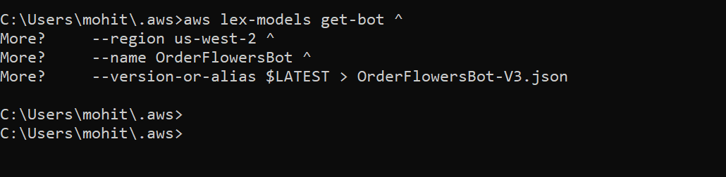

**Revision of the bot**

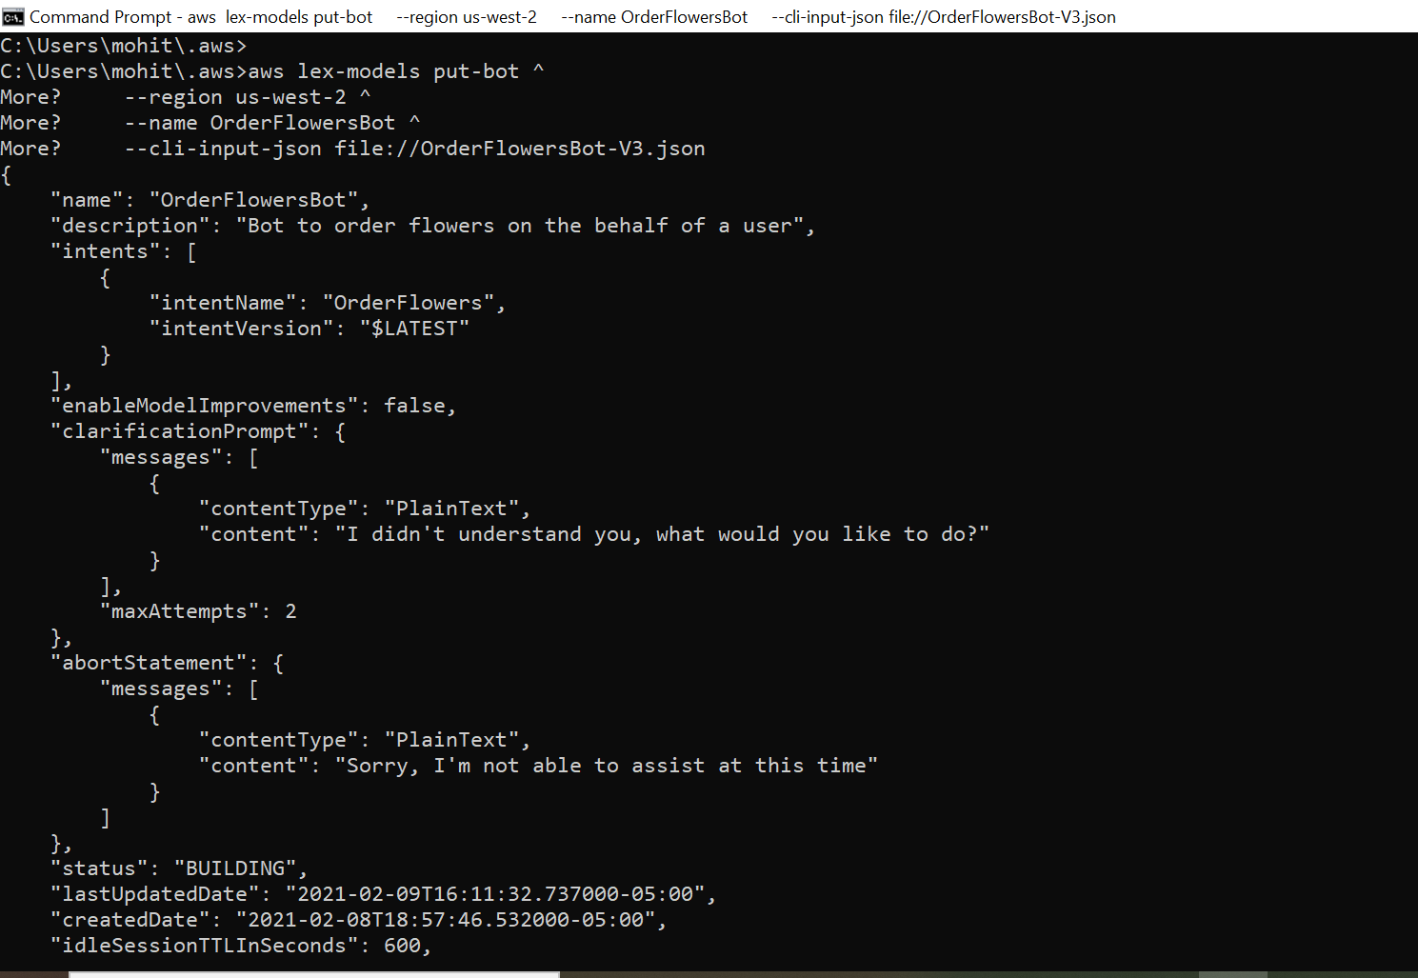

**Problem 4:**

<https://docs.aws.amazon.com/lex/latest/dg/gs-cli-publish.html>

**Step 1**: Publishing Slot Type

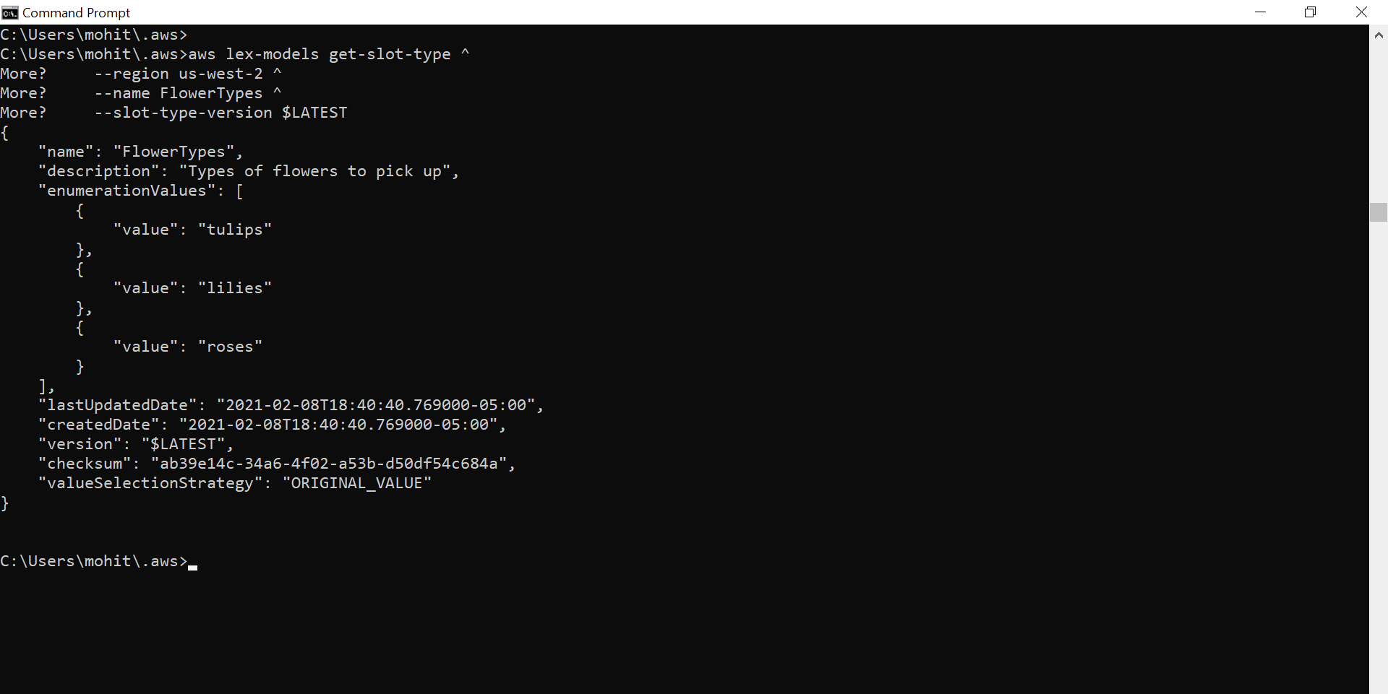

**Publish a version of slot type**

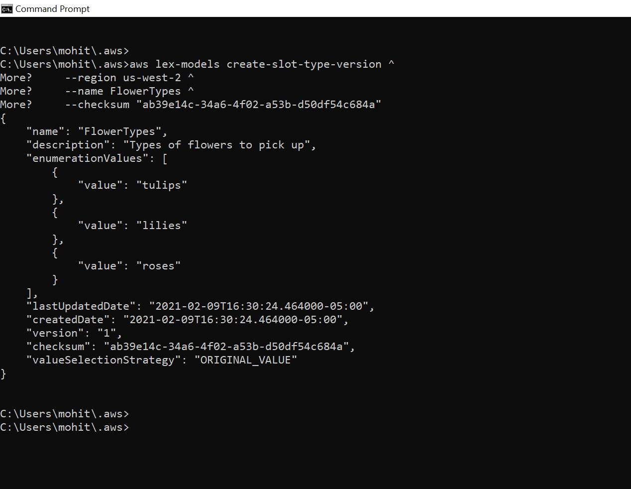

**Step 2: publish the intent**

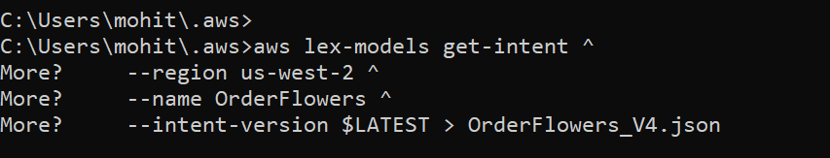

**Save the revision**

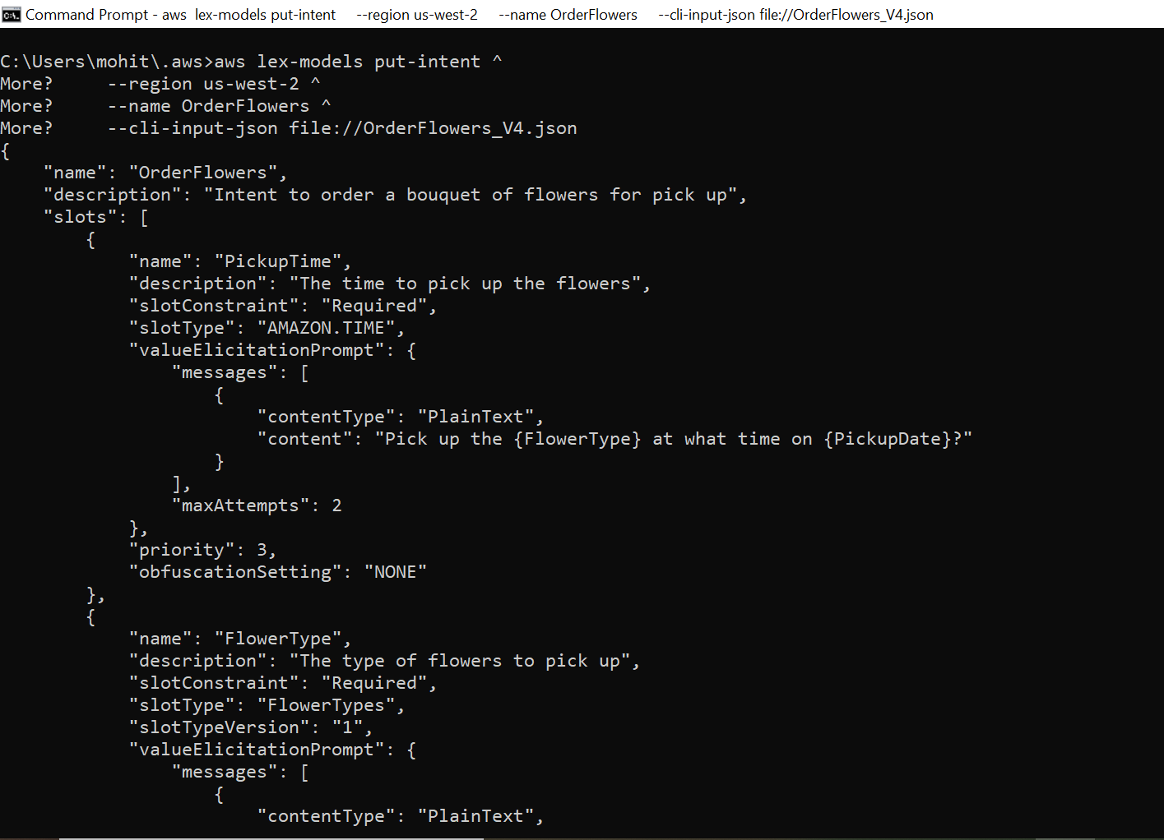

Get the checksum of the latest revision of the intent:

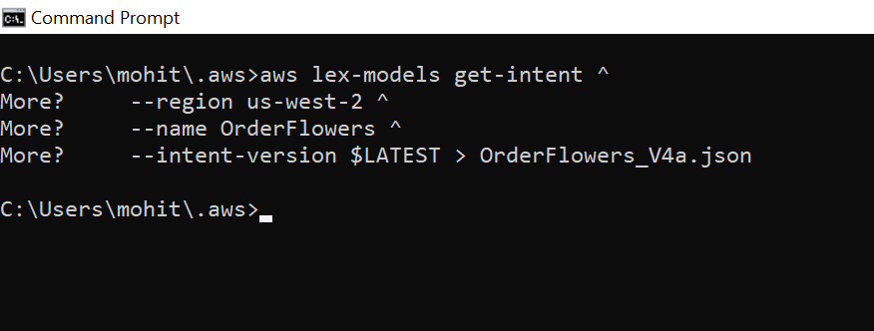

Publish a new version of the intent:

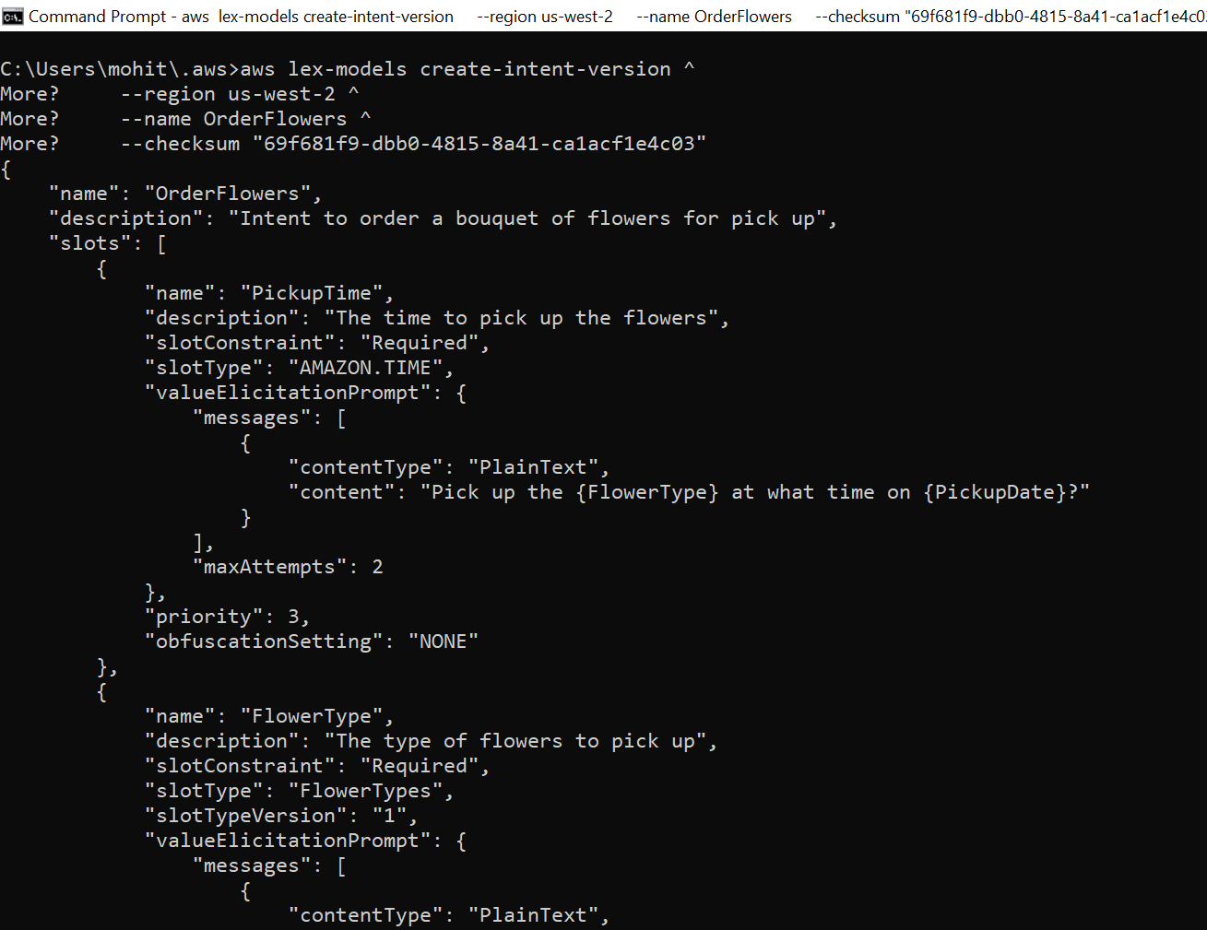

# Step 3: Publish the Bot (AWS CLI)

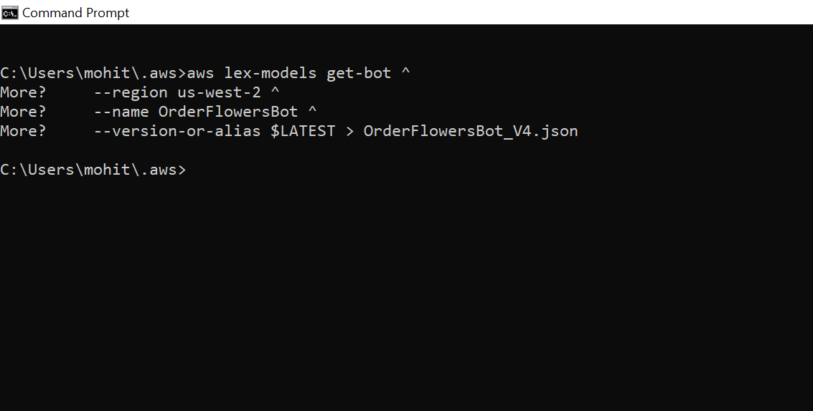

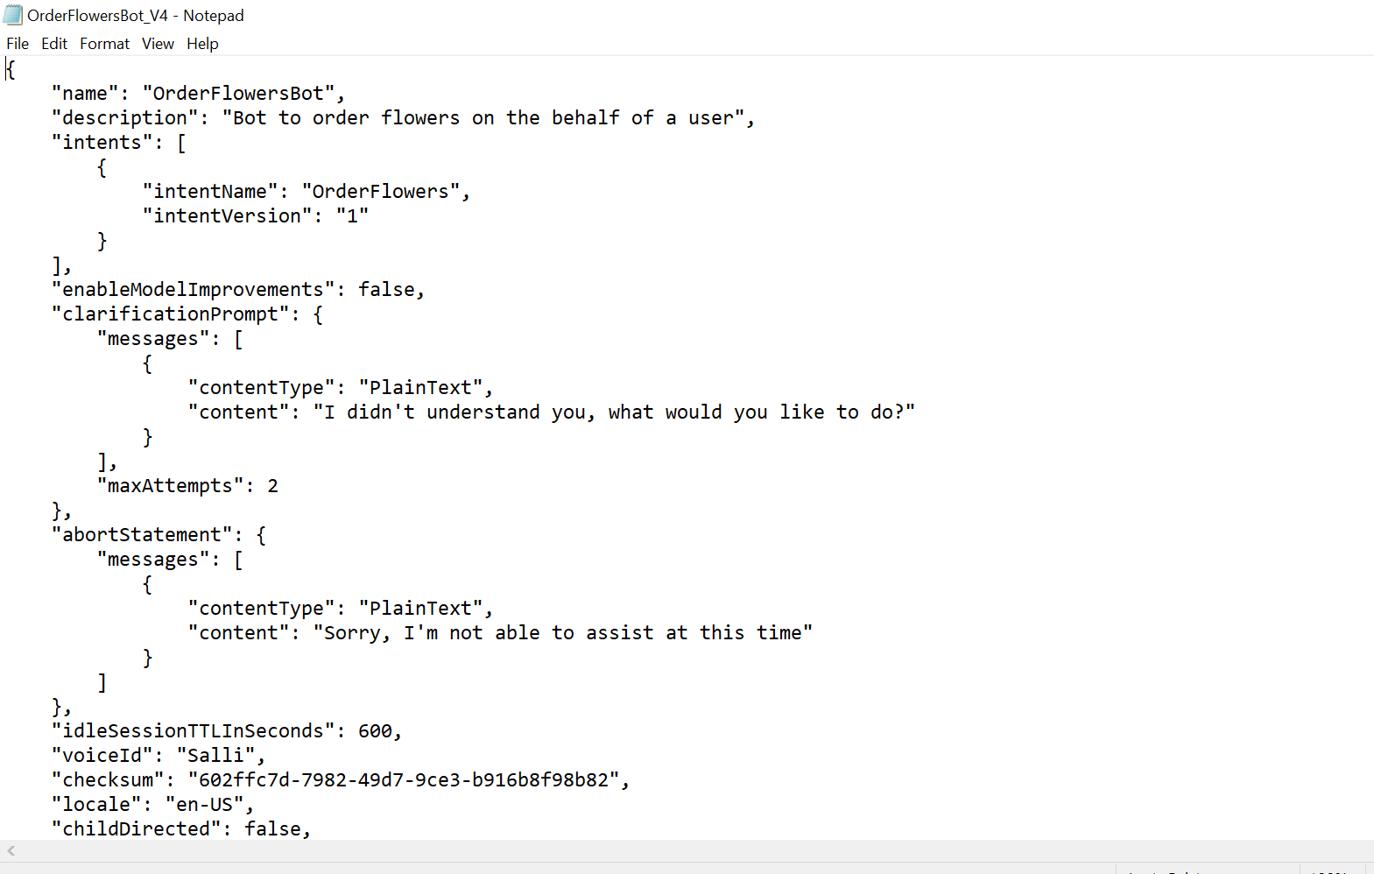

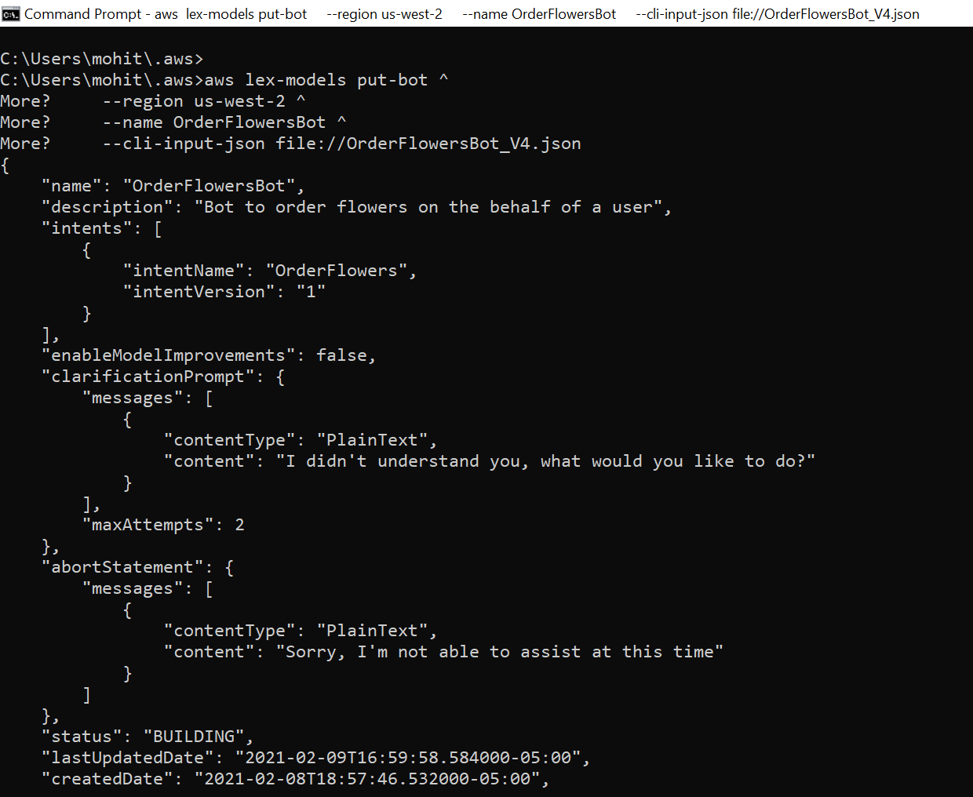

Get the checksum of the latest revision of the bot. Use the version number returned in step3.

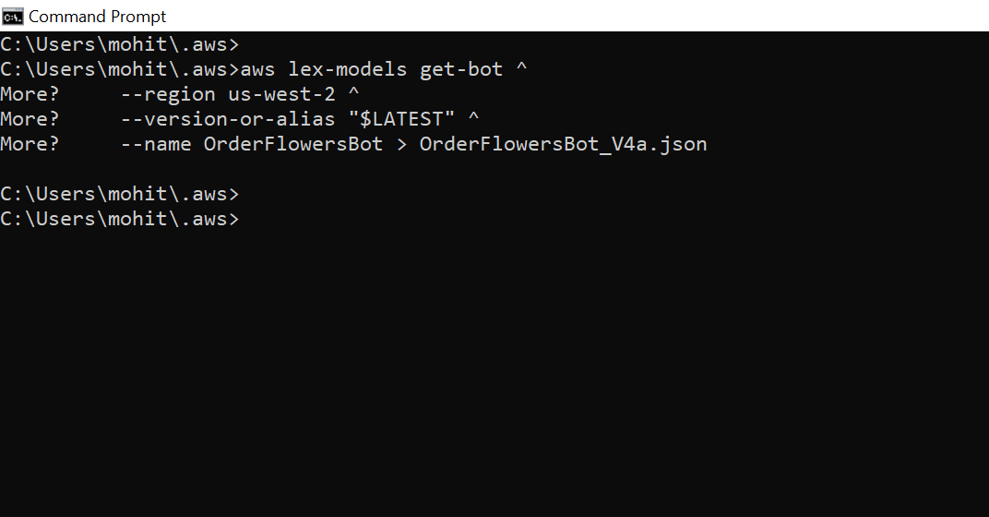

Publish a new version of the bot:

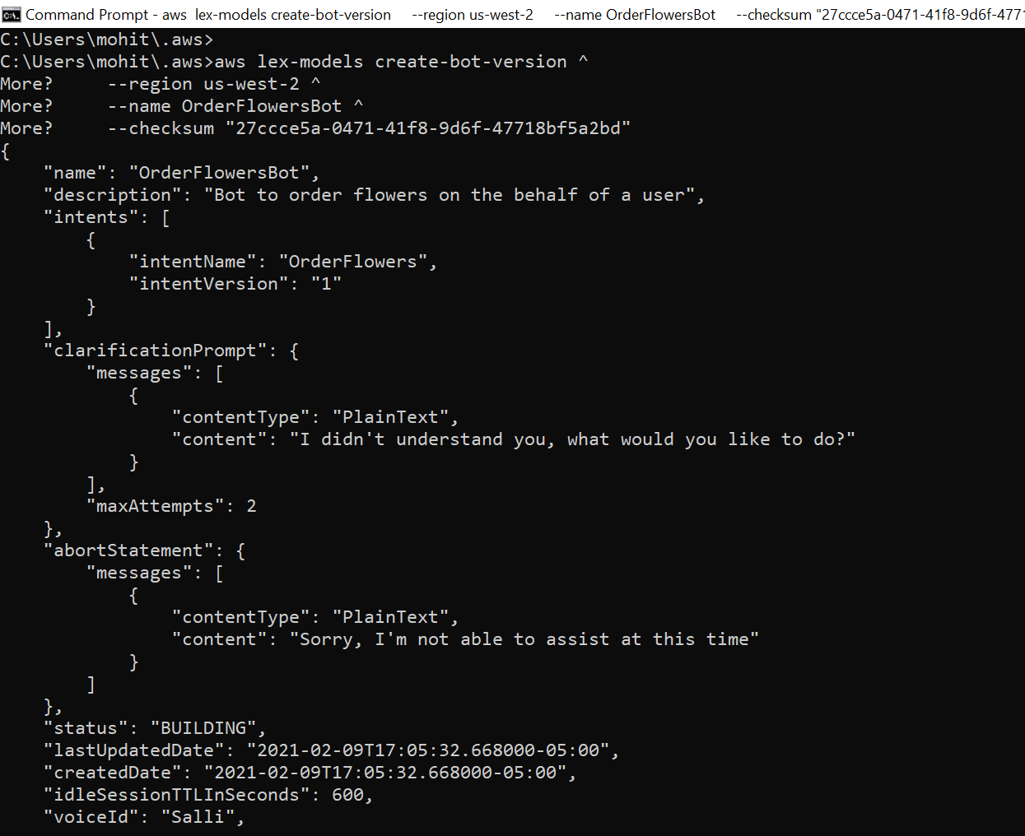

Put all your steps and screen captures here.

**Total points: 15**

**Problem 5:**

<https://docs.aws.amazon.com/lex/latest/dg/gs-cli-create-alias.html>

Put all your steps and screen captures here.

**Total points: 15**

# Exercise 5: Create an Alias (AWS CLI)

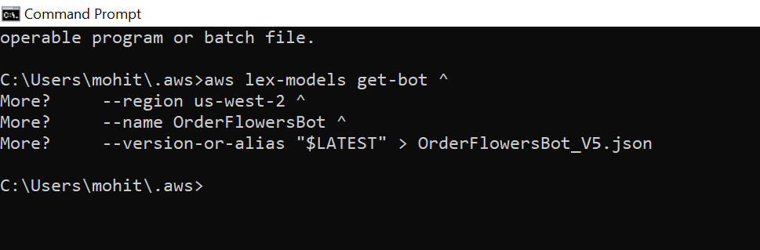

1. In a text editor, open **OrderFlowersBot_v5.json**. Find and record the version number.

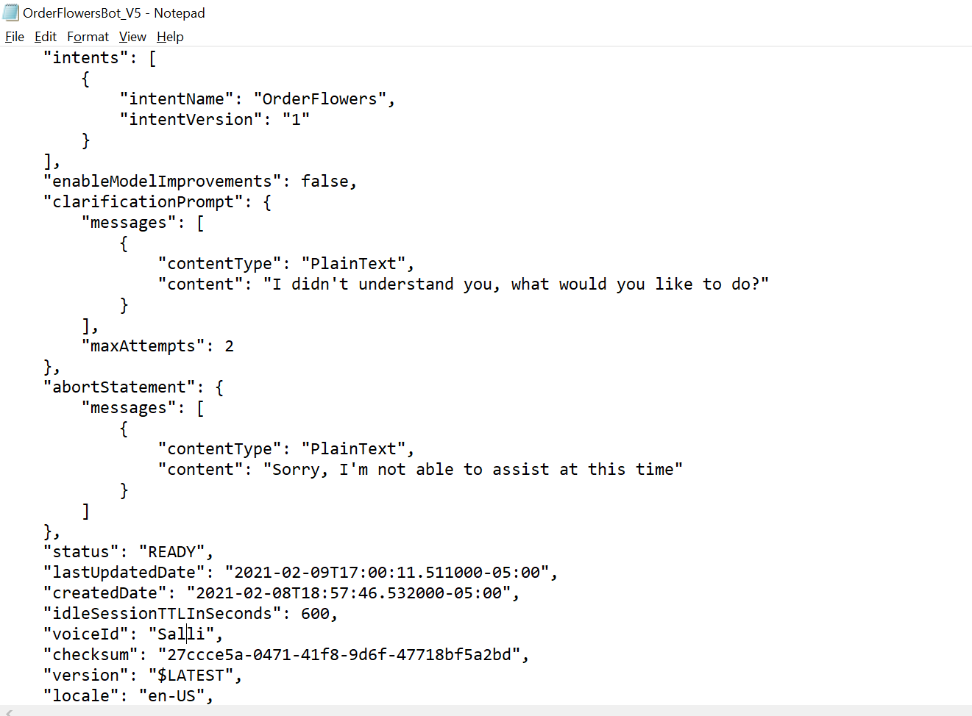

In the AWS CLI, create the bot alias:

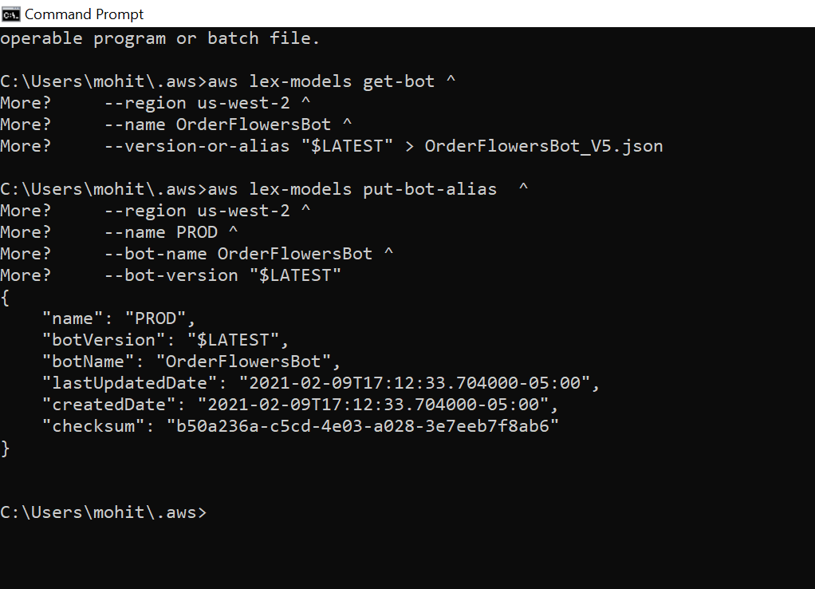

**Problem 6:**

<https://docs.aws.amazon.com/lex/latest/dg/gs-cli-clean-up.html>

Put all your steps and screen captures here.

**Total points: 10**

# Exercise 6: Clean Up (AWS CLI)

In the AWS CLI command line, delete the alias:

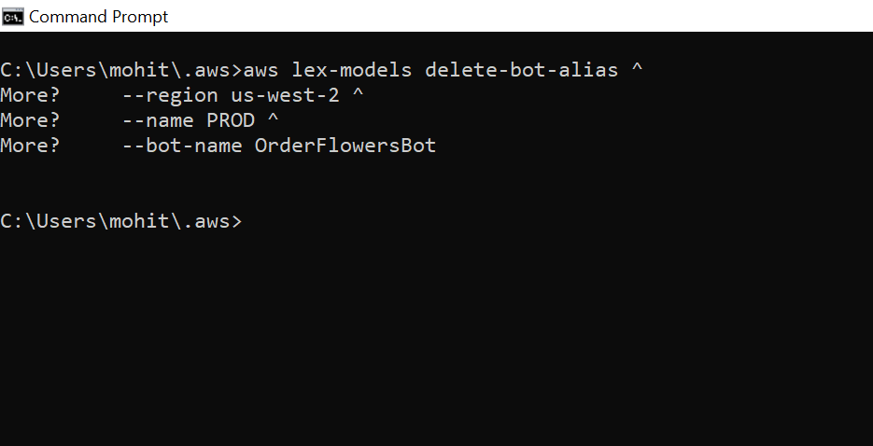

In the AWS CLI command line, delete the bot:

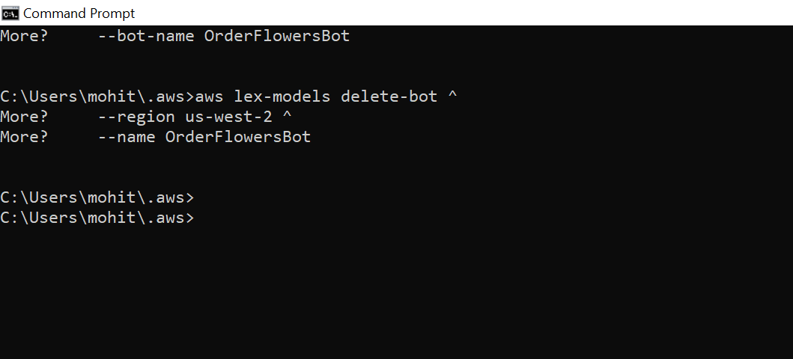

In the AWS CLI command line, delete the intent:

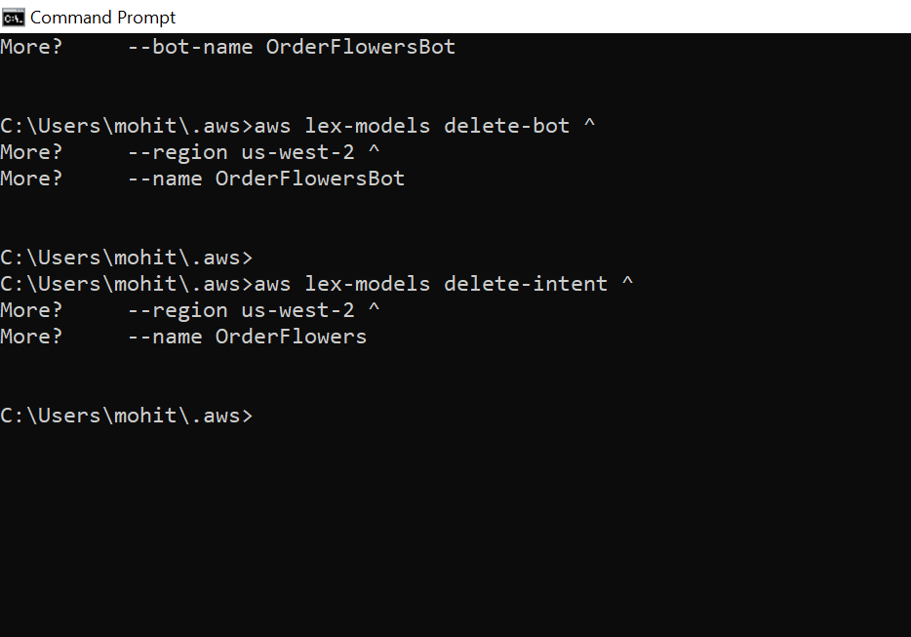

From the AWS CLI command line, delete the slot type:

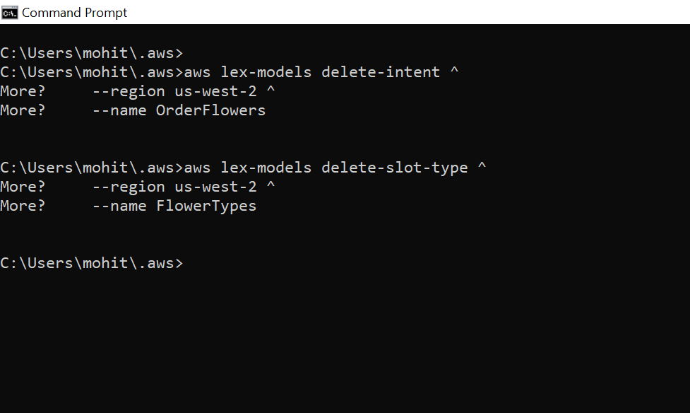

------------------------------------------------------------------------------------------------------------

Upload your MS Word document named: **ITC6460**_YourLastNameYourFirstNameHWXX.docx to the course web site in your folder for Assignment 1. Note: Do NOT include your JPEG files as separate files.

If you have issues with the upload, please notify your instructor! If you are raising issues that might be of interest to all of your colleagues in the class, please use the Discussion Board, Assignment XX thread on the course site. The Discussion Board is your best friend.